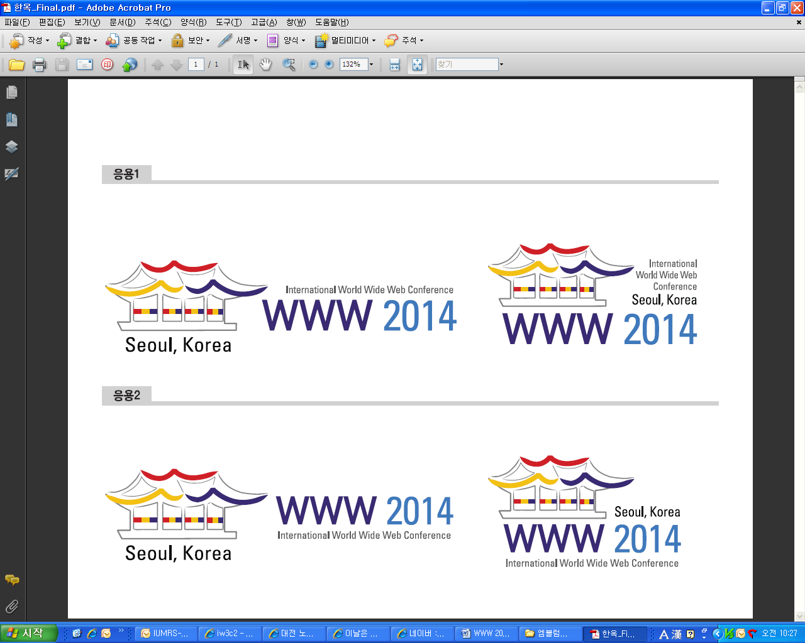
The 23rd International World Wide Web Conference
WWW 2014
April 7~11, 2014 / Coex, Seoul, Korea

Tour Reservation Form
Please refer to the website for details. For off-line reservation, type clearly in block letters and send this form to below.

Tour Bureau of WWW 2014 (Kim’s Travel Service Co., Ltd)
5F, 2728 Nambusunhwan-ro, Gangnam-gu, Seoul, Korea
Tel: +82-2-570-3569 Fax: +82-2-571-9921 E-mail: hotel@www2014.kr

- FOR TOUR RESERVATION

[General Announcement]

- Tour Reservation Deadline: 21 Mar, 2014
- All tour programs are requiring minimum person and if minimum number of persons is not reached, the programs
can be cancelled or substituted by another program with notice to participants, or may proceed at an altered rate
with the consent of all participants.
- Credit card info is required to secure your reservation and tour fee will be paid by given credit card when the tour
confirmed with the minimum person for each tour.
- All tours include entrance fee as per itinerary and touring with the service of an English speaking guide.
- All tours are based on the estimated price and tour courses could be changed later due to the local circumstances.

[Cancellation Policy] : All dates are based on Korean Time (GMT+9hrs).

Cancellation Request Dates | Policy
by March 20 (Sun), 2014 | No penalty
From Mar 21 (Mon), or No-show | No refund and full payment will be charged as penalty.

* No-show: do not attend the tour without any notice in advance

1. Participant Information (Please check the appropriate box and fill in the blanks below.)
First Name (Given Name): Last Name (Family Name):
Country: Organization: Job Title:
E-mail: Tel: M.P:
Address:
2. Tour Reservation (Please check the appropriate box and fill in the blanks below.)
Category | Program |  | Date | Time |  | Tour Price  /Person | No. of Person
Optional  Tour | DMZ Tour->Paju Premium Outlets |  | 8 APR (Tue) | [08:30~17:30] |  | 70,000/p.p
Optional  Tour | Korean Folk Village |  | 8 APR (Tue) | [13:00~17:00] |  | 67,000/p.p
Optional  Tour | Changdeokgung Palace >Insadong |  | 8 APR (Tue) | [12:45~17:00] |  | 82,000/p.p
Optional  Tour | Dongdaemun Shopping Town->  N Seoul Tower |  | 7 APR (Mon) | [19:00~23:00] |  | 69,000/p.p
Optional  Tour | Dongdaemun Shopping Town->  N Seoul Tower |  | 8 APR (Tue) | [19:00~23:00] |  | 69,000/p.p
Optional  Tour | Myeongdong->N Seoul Tower |  | 7 APR (Mon) | [19:00~23:00] |  | 69,000/p.p
Optional  Tour | Myeongdong->N Seoul Tower |  | 8 APR (Tue) | [19:00~23:00] |  | 69,000/p.p
Category | Program |  | Date |  |  | Tour Price  /Person | Min.  Person
Pre/Post  Tour | Gyeongju City Tour (2D1N) |  | 6 APR (Sun) | 7 APR (Mon) |  | 400,000/p.p
Pre/Post  Tour | Mt. Seoraksan Nat’l Park (2D1N) |  | 6 APR (Sun) | 7 APR (Mon) |  | 420,000/p.p
Pre/Post  Tour | Jeju Island Tour (3D2N) |  | 12 APR (Sat) | 14 APR (Mon) |  | 700,000/p.p
PAYMENT METHOD (Please give us your credit card information as following)
Payment Method |  | - Credit Card
Option 1:  Credit Card |  | □ VISA □ Master □ AMEX
 |  | Card Number:
 |  | Expiration Date (mm/yy): |  |  | CVC Number:*
 |  | Card Holder’s Name: |  |  | Card Holder’s Signature:
* Card Validation Code (CVC): AMEX: 4-digit number VISA or Master: 3-digit number.
※ I hereby authorize Kim's Travel Service Co., Ltd to debit my credit card.

