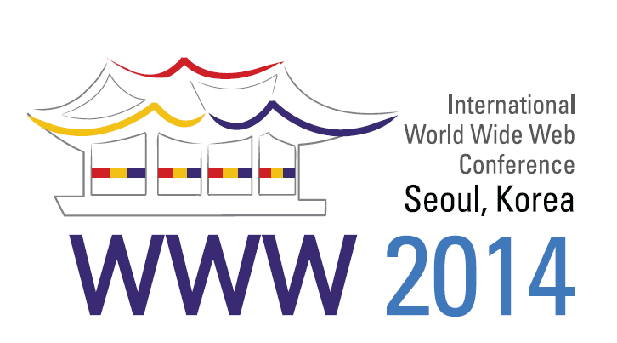

**WWW2014 Sponsorship Opportunities**

<http://www2014.kr>

We would like to invite you to participate as a sponsor of World Wide Web Conference 2014, Seoul, Korea, dedicated to the presentation of the latest research, development, standards, and applications of the topics related to the Web.

WWW 2014 will offer high quality technical activities including research sessions, workshops, and tutorials. Tracks will include the research track, demonstration track, developers track, and industry track.

WWW2014 is a highly selective conference with a high-quality technical program selected by an outstanding technical program committee. In addition, the conference includes a number of events, such as talks by visionary leaders in the field, demos of cutting edge research technologies, and workshops on topical issues, which provide attendees ample opportunities for learning, debating, and exchanging information. The conference typically attracts about one thousand attendees (in each of the past several years), including influential technical leaders from academia, industry, and government as well as students from across the world.

WWW2014 will be held during April 7 - 11 in Seoul. The conference will present an excellent opportunity for you to get your company's brand and message across to the world's leading computer professionals, technology decision makers, and potential future employees. World Wide Web conferences have traditionally received strong financial support from industry, with several companies having consistently supported the conference over the past years or longer. We expect to continue to receive such strong support for WWW2014 from our industry partners, including, we hope, your company.

Listed below on page 3 are some of the opportunities that you can avail of for gaining visibility for your company at WWW2014 by becoming a sponsor.

Sincerely,

Local Organizing Committee, WWW 2014

**Conference Overview**

* Title: The 23rd International World Wide Web Conference
* Date: April 7 – 11, 2014
* Venue: Coex, Seoul, Korea
* Organizers: IW3C2

KAIST (Korea Advanced Institute of Science and Technology)

MOTIE (Ministry of Trade, Industry & Energy) / KATS (Korean Agency for Technology and Standards)

**Programs &Technical Areas of Interest**

WWW2014 is a 5-day event featuring the following programs and tracks:

|  |  |
| --- | --- |
| * Research Track * Posters Track * Demo Track * Developers Track * Industry Track * Panel | * PhD Symposium Track * Tutorial * Web Science Track * Workshop * W3C Track |

The areas of interest of the WWW2014 conference include but are not limited to:

* Behavioral Analysis and Personalization
* Content Analysis
* Crowd Phenomena
* Internet Economics and Monetization
* Security, Privacy, Trust, and Abuse
* Semantic Web
* Social Networks and Graph Analysis
* Software Infrastructure, Performance, Scalability, and Availability
* User Interfaces, Human Factors, and Smart Devices
* Web Mining
* Web Search

BigData Innovators Gathering (BIG) 2014 will be co-located with WWW2014.

**Sponsorship Options**

WWW2014 welcomes corporate support and offers a variety of ways in which companies can participate as a sponsor. Information on the sponsor opportunities, including benefits and amount, are given in page 3.



**Sponsorship Guideline**

**(WWW2014 + BIG2014)**

**▶For Title Sponsors**

|  |  |  |  |  |  |
| --- | --- | --- | --- | --- | --- |
| **Benefits** | | **Platinum** | **Gold** | **Silver** | **Bronze** |
| **Items** | **Details** | **USD 70,000**  **(KRW 77,000,000)** | **USD 50,000**  **(KRW 55,000,000)** | **USD 30,000**  **(KRW 33,000,000)** | **USD 15,000**  **(KRW 16,500,000)** |
| **Exhibition** | **One exhibition booth** | **24sqm (4m X 6m)** | **15sqm (3m X 5m)** | **9sqm (3m X 3m)** |  |
| **Registration** | **Free registration (Full Pass)** | **5** | **4** | **3** | **2** |
| **Conference** | **Sponsor introductions at opening ceremony** | **√** | **√** | **√** | **√** |
| **Presentation at**  **Industry Session** | **√** | **√** |  |  |
| **On-site Publicity** | **Logo on banners** | **√** | **√** | **√** | **√** |
| **Logo on Conference Kit** | **√** | **√** |  |  |
| **Logo on screen at Opening/Closing/Plenary** | **√** | **√** |  |  |
| **Promotional materials**  **inside Conference Kit** | **√** |  |  |  |
| **On-line Publicity** | **Position of Sponsor's Banner**  **on Conference Website (Main and Sponsors Pages)** | **First Row** | **Second Row** | **Third Row** | **Fourth Row** |
| **Logo on official newsletter** | **√** | **√** | **√** |  |
| **Web Link for**  **Promotional Material**  **(Sponsors Page)** | **√** |  |  |  |
| **Printed matters** | **Logo on Program Booklet** | **√** | **√** | **√** | **√** |
| **Advertisement**  **on Program Booklet** | **1Page(Cover Page)** | **1Page** | **1/2 Page** |  |
| **Logo on official documents and promotional materials** | **√** | **√** |  |  |

**▶For Item Sponsors**

|  |  |  |
| --- | --- | --- |
| **Item** | **Price** | **Benefits** |
| **Gala Dinner** | **USD 20,000**  **(KRW 22,000,000)** | **- Logo on Program Booklet - Logo on conference website (Sponsors page) - Sponsors banner at Gala dinner** |
| **BIG2014 Dinner** | **USD 10,000**  **(KRW 11,000,000)** | **- Logo on Program Booklet of BIG2014**  **- Logo on BIG2014 website and sponsors page of**  **WWW2014 - Sponsors banner at BIG2014 dinner** |
| **Wifi** | **USD 10,000**  **(KRW 11,000,000)** | **- Logo on Program Booklet**  **- Logo on conference website (Sponsors page) - Sponsors banner at Lobby(1F)** |
| **Registration Desk**  **(Incl. Kit Desk)** | **USD 8,000**  **(KRW 8,800,000)** | **- Logo on Program Booklet**  **- Logo on conference website (Sponsors page)**  **- Logo on registration desk** |

**▶For more details, please feel free to contact:**

**WWW2014 Secretariat**

E-mail: [www2014@www2014.kr](mailto:www2014@www2014.kr)

Website: <http://www2014.kr>

**Sponsorship Application Form**

* Please fill out the application form below, and send it back to the secretariat

|  |
| --- |
| WWW 2014 Secretariat  5F Daehan Bldg., #1018, Dunsan-dong, Seo-gu, Daejeon, Korea  [Tel:+82-42-472-7460/ Fax:+82-42-472-7459](Tel:+82-42-472-7460/%20Fax:+82-42-472-7459)  E-mail: www2014@www2014.kr |

1. **Information of the Company**

|  |  |  |  |
| --- | --- | --- | --- |
| Company Name | *This is exactly how your company name will appear on your signage and other materials.* | | |
| Main Contact |  | | |
| Department |  | | |
| Address |  | | |
| Zip Code |  | Country |  |
| Tel |  | Fax |  |
| E-mail |  | | |

**2. Sponsorship**

- Please fill out the table below.

|  |  |  |
| --- | --- | --- |
| **[TYPE]** | **Amount** | **Requests** |
|  |  |  |
|  |  |  |

* Please give us the expected date of your deposit.

Day: Month: Year:

**3. Payment**

Payment should be made via bank transfer. WWW2014 requires payment in full before we can confirm your company’s participation at WWW2014. The sooner you send your form, the greater exposure your company will get via all conference related correspondence and web presence.

**Account Information**

* Account Holders: **The Korean Institute of Information Scientists and Engineers**
* Account No.: **1005-901-554787**
* Bank Name: **Woori Bank**
* Address of Bank: **1585, Sangam-dong, Mapo-gu, Seoul, Korea**
* Swift Code: **HVBKKRSEXXX**

Date: _______________________________________

Signature: _________________________________